**14. Aim:** To Design Push Down Automata using simulator to accept the input string anb2n .

**Diagram:**

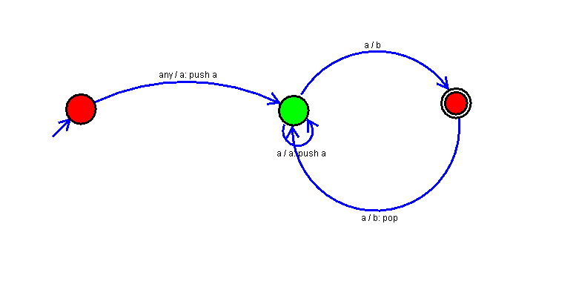

**Result:**

Thus, successfully executed Push Down Automata using simulator to accept the input string anb2n .